**ONLINE SUPERMARKET**

**Name : RISSHITH BS**

**REG NO : 192210021**

**Create a simple cloud software application for online super market using any Cloud Service Provider to demonstrate SaaS with the template of customer name, address, phone, email, items, quantity etc. with the item classification form**

**AIM:**

Create a simple cloud software application for Property Buying & Rental process (In Chennai city) using any Cloud Service Provider

**PROCEDURE:**

**STEP 1:**

Open browser and get into zoho creator. Then sign in and click “Create application”. Below given screenshot will appear, hear type the application name of your Aim.

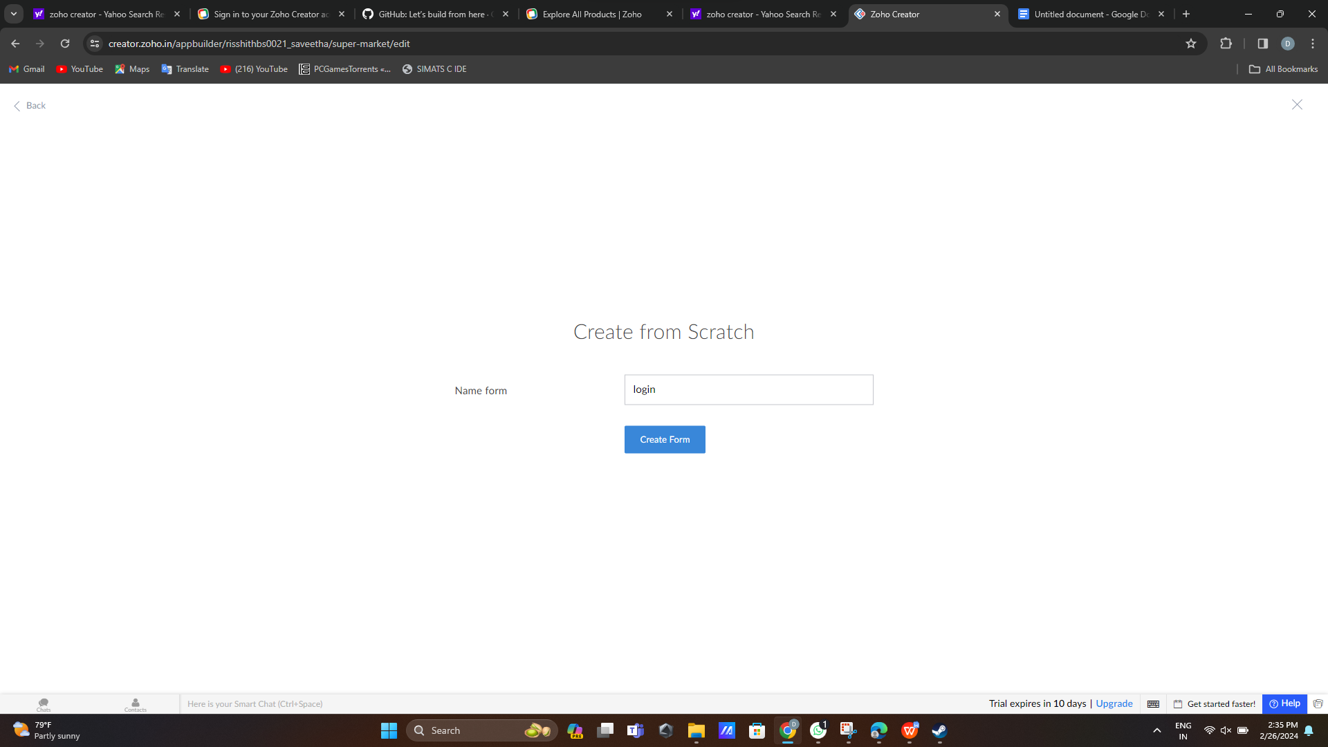STEP 2: create login form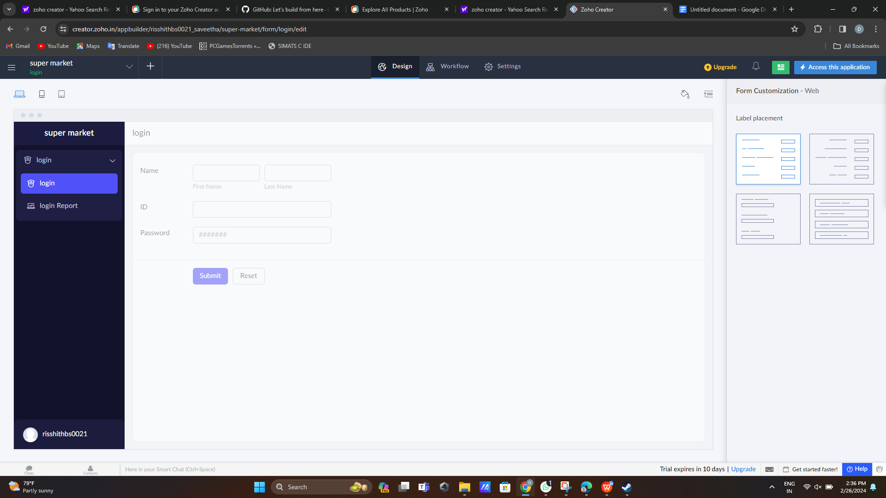STEP 3:create item search form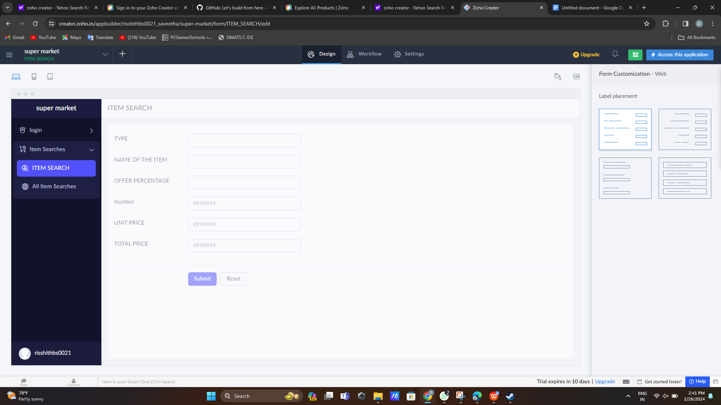STEP 5: create customer form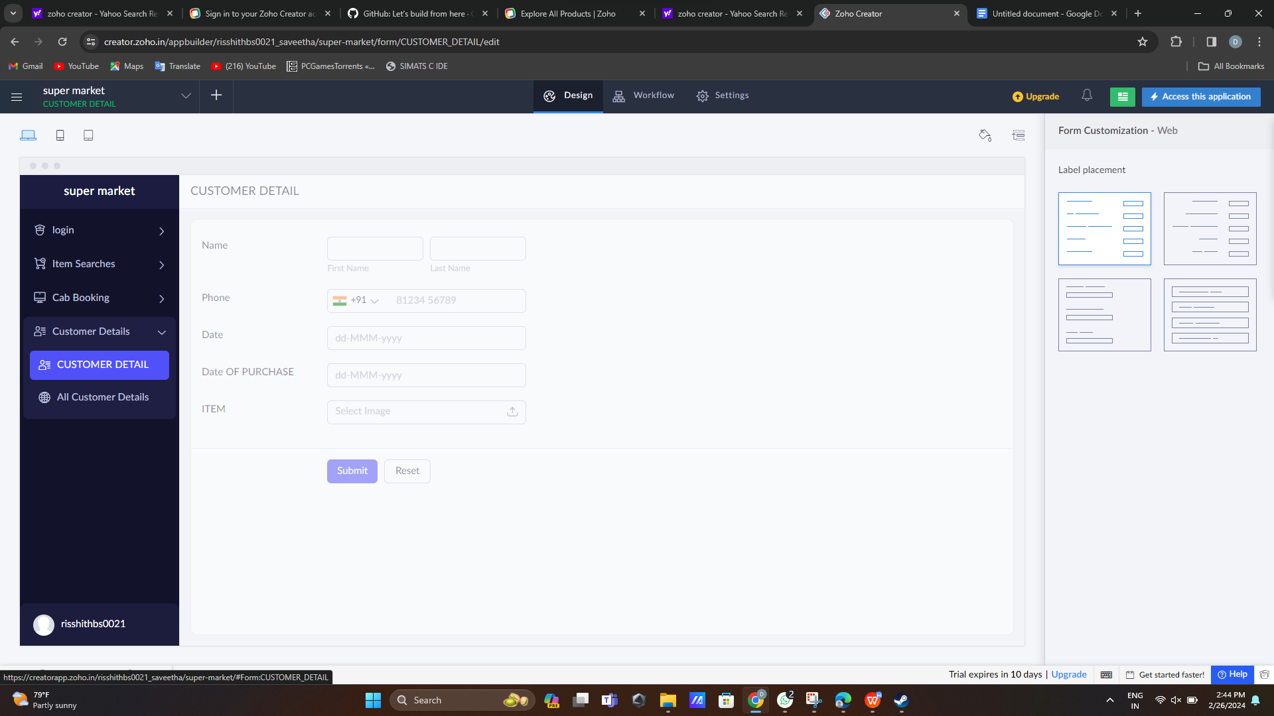STEP 6:create sign out form